A poem about pets

I’ve got a dog
His name is Fog
It is Fog the dog

I’ve got a cat
And she is very fat,
She is a fat, fat cat

I’ve got a hamster
His name is Peter
It is Peter the hamster

I’ve got a guinea pig
And she is very big,
She is a big, big guinea pig

I’ve got a bird
His name is Third
It is Third the bird

And to finish,
I have a goldfish
His name is Dish
It is Dish the goldfish!

Cut and stick to the right place:
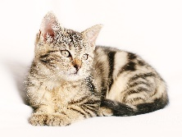 | 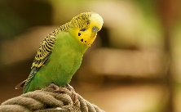 | 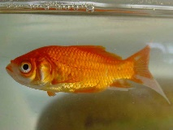
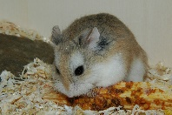 | 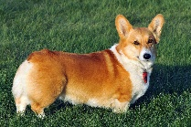 | 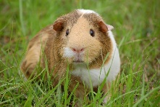
A. Noué CPD LV 16

