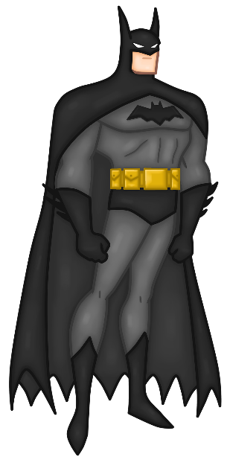 | 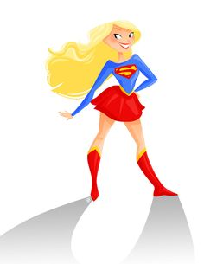 | 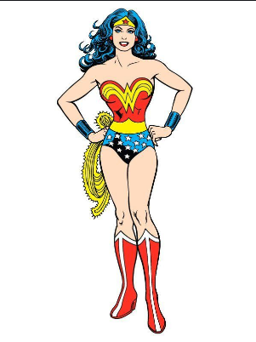
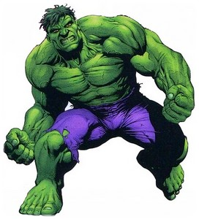 | 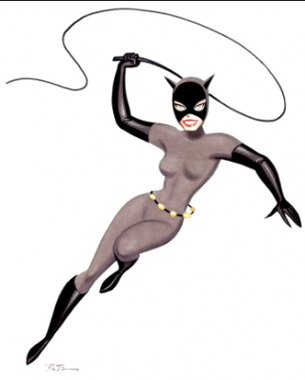 | 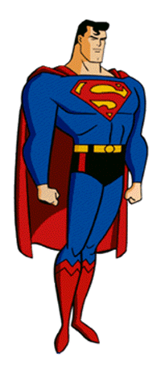

He is tall and strong.  He has got a black cloak , a black mask and black boots.  He has got a yellow belt and two long black gloves.  He is ………………... | She is tall and thin.  She has got a grey suit and two black gloves and black boots. She has got a lasso.  She is ……………… | He is fat and very strong.  He has got short dark hair.  He has got purple shorts.  He has got a lot of muscles.  He is green.  He is ………………………
She has got long blond hair and a happy face.  She has got a red skirt, a blue tee-shirt, and red boots.  She is ……………………… | He is tall and strong.  He flies.  He has got short dark hair and blue eyes.  He has got a red cloak , a blue suit and red boots.  He is ……………………… | She is tall.  She has got long curly hair.  She has got earings. She has got a yellow belt and red and white boots.She has got a red and yellow top.  She is ………………...

