Des lectures
https://www.lumni.fr/video/la-moufle

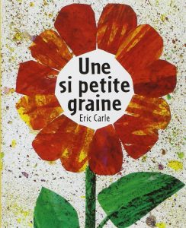Une si petite graine
https://drive.google.com/file/d/1jwB3au-GRx1bETPabkYbp6DhCDYdHCt6/view
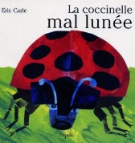La coccinelle mal lunée
https://drive.google.com/file/d/0By8FVC15OWBSUFpEZkNCT1JrSFk/view

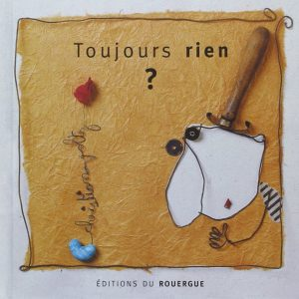Toujours rien ?
https://drive.google.com/file/d/19u3O5DAzT9_-Kgi-ikIX0xL3eiYsLQI8/view

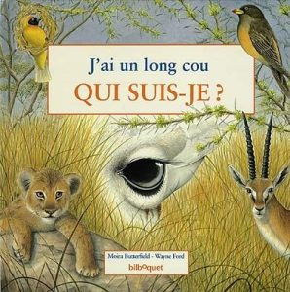J’ai un long cou, qui suis-je ? https://read.bookcreator.com/UL3iS9LyjkT59Z0fOcboHZOOLZg2/mbj4wjByTKOaDSGvr8HO0w
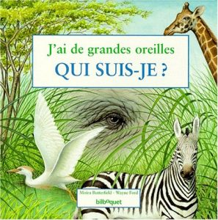J’ai de grandes oreilles, qui suis-je ?
https://read.bookcreator.com/UL3iS9LyjkT59Z0fOcboHZOOLZg2/u8bQO1HdQJaCy3ss6YquAA

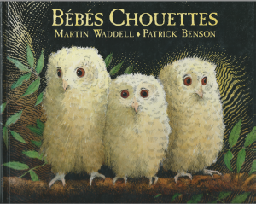Bébés chouettes
https://read.bookcreator.com/pBsqxYSMMwYOfjsn57ra2uQQxfq2/Up_azUgVQpiGUbzto2HxzQ
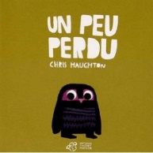Un peu perdu
https://read.bookcreator.com/pBsqxYSMMwYOfjsn57ra2uQQxfq2/QOx9lPH3Q3Wt1PIszVQuDA
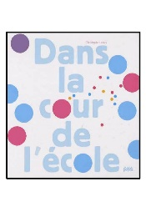https://read.bookcreator.com/pBsqxYSMMwYOfjsn57ra2uQQxfq2/JDDI1RGvRi22_nw4sfXExA

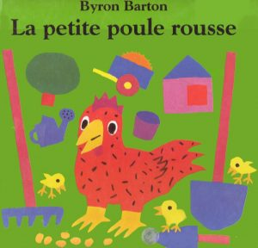 https://read.bookcreator.com/pBsqxYSMMwYOfjsn57ra2uQQxfq2/NNMwH3B5RSWZ1Vut_ZBn0g

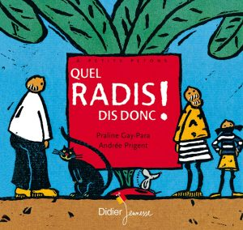https://read.bookcreator.com/bq1V1kwOeORM6BIKXL4AM9376MS2/alAgJuu-Qt-lLLGSAuXGHA
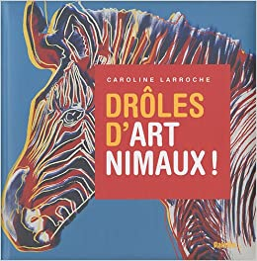https://read.bookcreator.com/pBsqxYSMMwYOfjsn57ra2uQQxfq2/Bz6zx9uER1aERMpVNbI5BQ
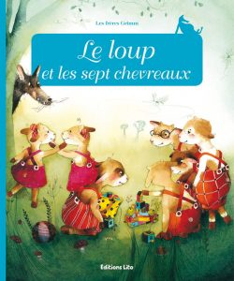https://read.bookcreator.com/RztMCQfV1bUdINETanDXgQmLA1s1/pvml3HfyRJ-2TgHdGky0Fw

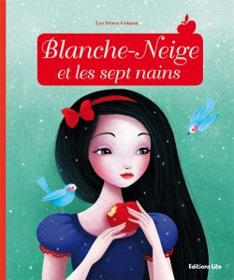https://read.bookcreator.com/RztMCQfV1bUdINETanDXgQmLA1s1/aIaRR2JNRAmt_7hn-7gbuA

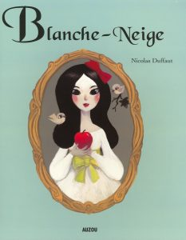https://read.bookcreator.com/pBsqxYSMMwYOfjsn57ra2uQQxfq2/V_5qTytrQ2ip9ObIYb3ijA

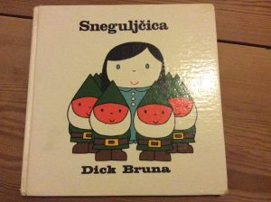https://read.bookcreator.com/pBsqxYSMMwYOfjsn57ra2uQQxfq2/2jzg77UbQO2lxI7eRw1LoA
Et une autre version de Blanche-Neige. Sans texte, celle-là !

